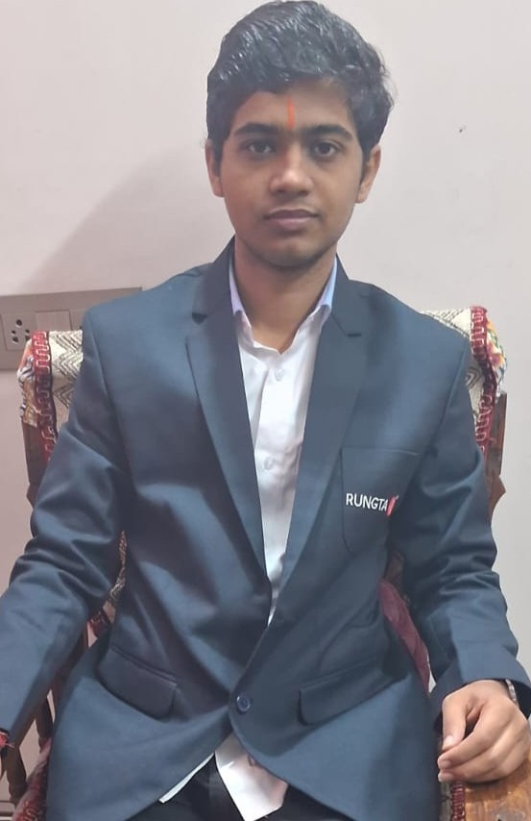 |  | Akshat Rahangdale
Profile  Enthusiastic and quick-learning graduate with a solid foundation in technical and analytical skills. Eager to apply knowledge, contribute to team goals, and grow through real-world experience.  Contact  PHONE:  62617-99795  LinkedIn:  www.linkedin.com/in/ akshat-rahangdale-651186383  EMAIL:  Akshatrahangdale31@gmail.com  Hobbies  Hobby #1  Hobby #2  Hobby #3  Hobby #4 |  | EDUCATION  [Shivansh International School]  [2023-25]  [I have got 82% in my 10th standards and 66% in my 12th standards]  [Rungta International Skill University]  [2025] – [2029]  Currently in my 1st semester of Computer Science Engineer]  SKILLS

